How to Remove Picture Backgrounds
Students can remove backgrounds from pictures of themselves and then place themselves into different pictures. Students take a picture then use the magic wand to carefully remove the background. Saving the new image as a .png file will ensure that the background remains transparent.
Step One:
In Paint.NET, open the picture with the simple background. File >Open. On the Tools toolbar, click the magic want tool.
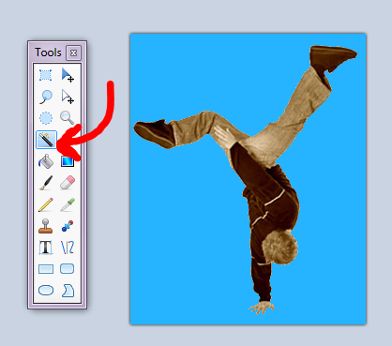
Step 2:
Click the magic want tool on the blue background of the picture. Then click delete on your keyboard. It should remove all of the blue background. If needed, use the tolerance slider to get more or less of the background when you delete. The grey and white squares indicate that the background has been removed. Important: Save this image as a .png file. The “portable network graphics” file will allow you to save the image with a transparent background. File>Save as>Save as type of file.
Step Three:
Open the background picture. File > Open.
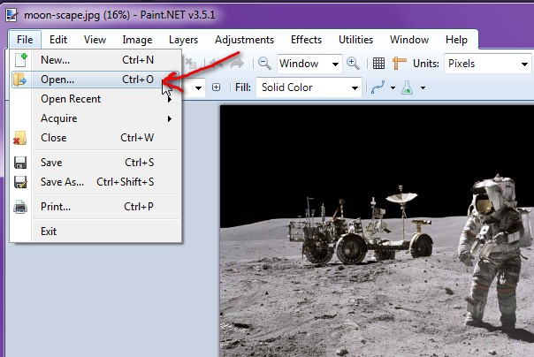
Step Four:
Import the image with the transparent background onto the background layer. Layers>Import From File. Resize and position the image as necessary. When finished, Save the combined images as a .jpg file ( which is properly called JPEG, stands for Joint Photographic Experts Group) and choose to “flatten” the image before saving.
