Tagxedo: Making Word Clouds!
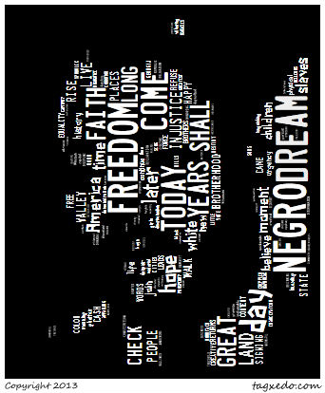
Objective: Students will be creating word clouds using words that they find from a website or that they import using a website.
Steps:
- Go to Google Images and find an image of Martin Luther King, Jr.
- Choose the image and “save as” into your Student file labeled MLKpic
- Open the Word Document, on the computer class website www.nicolasclassroom.weebly.com
and Copy the text of the “I Have a Dream” speech by Martin Luther King, Jr.
- Go to the Tagxedo website: http://www.tagxedo.com/app.html
- After that then press the link that is load.
- Students will go the box that has: Enter Text and paste the information from the “I Have a Dream” speech by Martin Luther King, Jr.
- After loading the text students will then decide on the following aspects for their word cloud:
-Shape (Click on the Shape arrow and click on Add Image, insert the image of Martin Luther King, Jr. you had saved earlier in the assignment.)
-Theme
-Font
-History (You can look at your history by clicking on the link.)
How to Save your Project:
- After creating and choosing your options students will:
-Save
-Chose the option of:125JPG and click on the number.
-When the save as option comes up you will do the following steps:
- Click on StudentFile
- Click on your class number
- Click on your name
- Name the file: Tagxedo

http://www.tagxedo.com/app.html

